**SQL_Assignment-3 🡪14/07/2021**

**/*Creating Employee and Department Tables */**

**create** **table** department_sr(

dep_id **int** **not** **null** **primary** **key**,

dep_name **varchar**(50)

);

**create** **table** employee_sr(

emp_id **int** **not** **null** **primary** **key**,

emp_name **varchar**(50),

emp_salary **int**,

dep_id **int**,

**foreign** **key**(dep_id) **references** department_sr(dep_id)

);

**/*Inserting Values into the tables */**

**insert** **into** department_sr **values**

(1,'Accounting'),

(2,'Research'),

(3,'Sales'),

(4,'Operations'),

(5,'Testing'),

(6,'Development'),

(7,'HR');

**insert** **into** employee_sr **values**

(1,'Smith',50000,7),

(2,'Allen',30000,3),

(3,'Ward',60000,6),

(4,'Jones',30000,5),

(5,'Martin',50000,1),

(6,'Blake',40000,1),

(7,'Clark',35000,2),

(8,'Scott',55000,3),

(9,'King',60000,5),

(10,'Turner',50000,4),

(11,'Adams',55000,7),

(12,'James',45000,3),

(13,'Ford',65000,2),

(14,'Miller',55000,6);

**select** * **from** employee_sr;

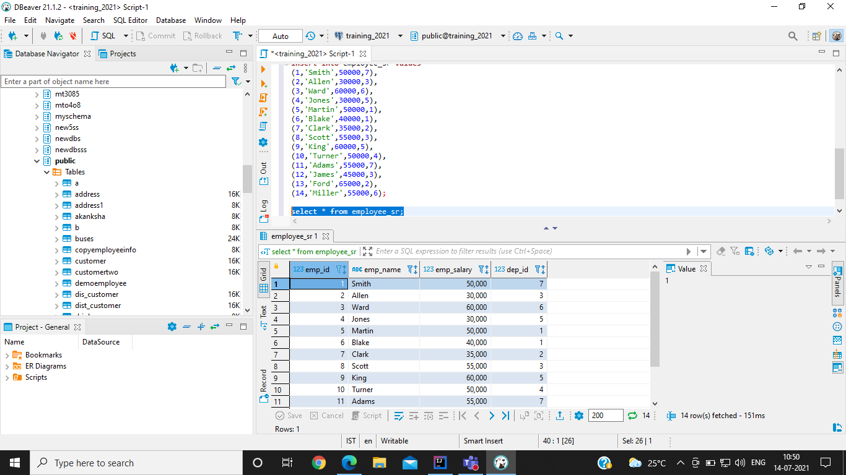

**select** * **from** department_sr;

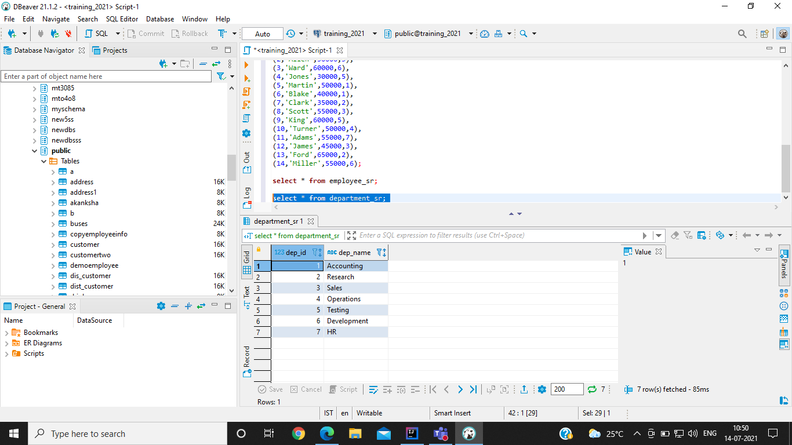

**/* QUERY-1 [dep_name, employee_count]*/**

**select** department_sr.dep_name, **count**(employee_sr.emp_id) **as** employee_count

**from** employee_sr

**left** **join** department_sr **on** department_sr.dep_id = employee_sr.dep_id

**group** **by** dep_name;

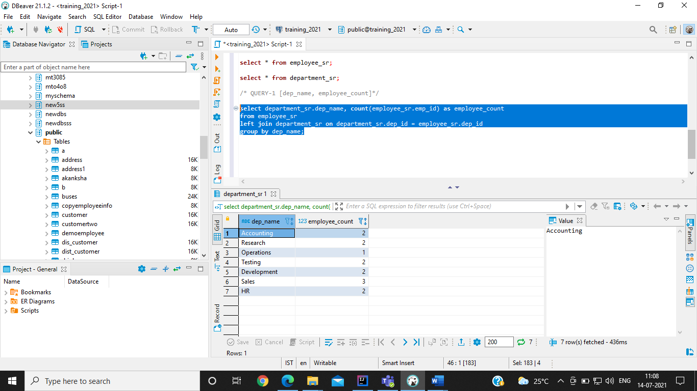

**/* QUERY-2 [dep_name, employee with max salary in the respective department] */**

**select** department_sr.dep_name, employee_sr.emp_name

**from** department_sr

**left** **join** employee_sr **on** employee_sr.dep_id = department_sr.dep_id

**where** (employee_sr.dep_id, employee_sr.emp_salary) **in** (**select** dep_id, **max**(emp_salary) **from** employee_sr **group** **by** dep_id);

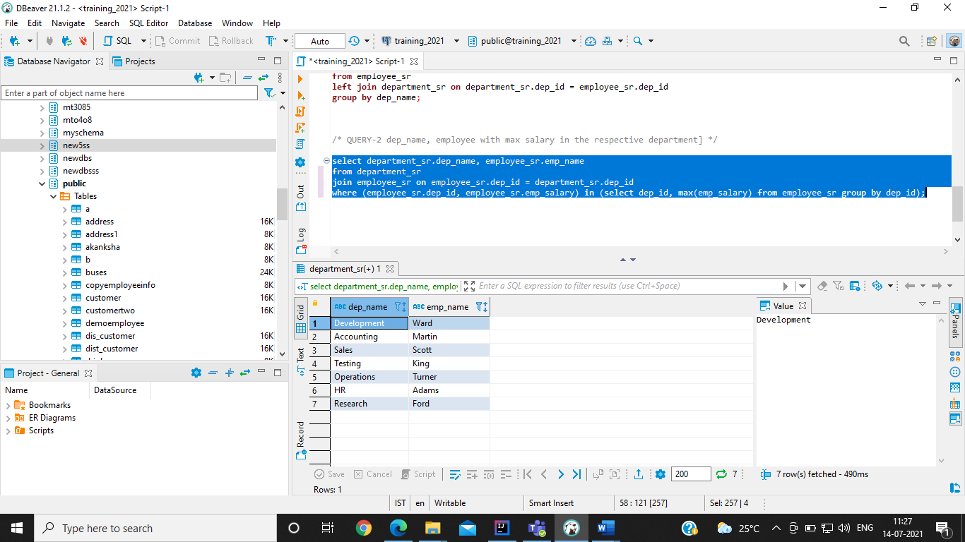

**/* QUERY-3 [dep_name,emp_name having salary greater than avg salary overall] */**

**select** department_sr.dep_name, employee_sr.emp_name

**from** department_sr

**inner** **join** employee_sr **on** employee_sr.dep_id = department_sr.dep_id

**where** emp_salary > (**select** **avg**(emp_salary) **from** employee_sr);

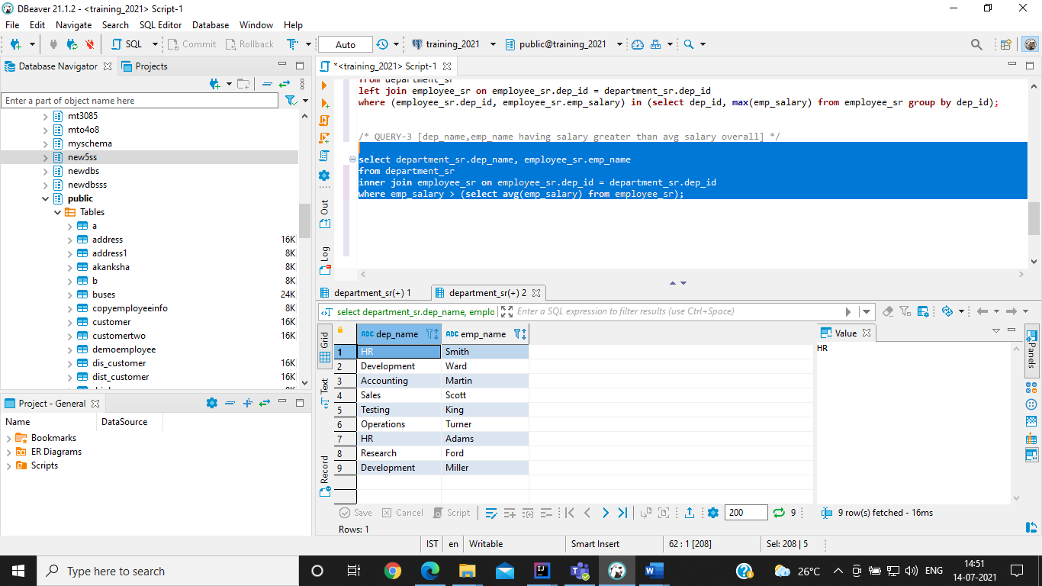

**/* QUERY-4 [dep_name,emp_name having salary greater than avg salary dep wise]*/**

**/* Display avg salary dept vise*/**

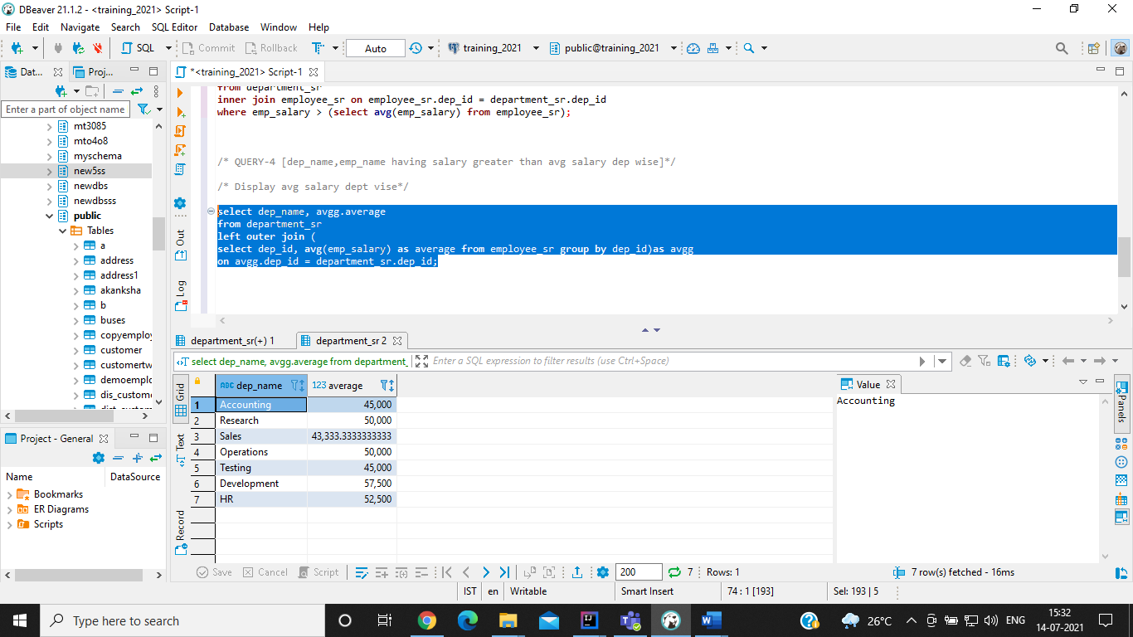

**/* Query -4 */**

**SELECT** dep_id, emp_name, emp_salary

**FROM** employee_sr e

**WHERE** emp_salary > (**select** **avg**(emp_salary) **from** employee_sr e2 **where** e2.dep_id = e.dep_id)

**order** **by** dep_id;

